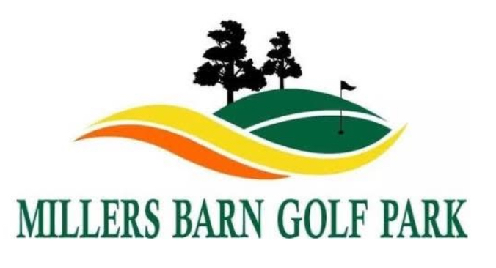
Millers Barn Golf Park Logo

Millers Barn Golf Park – Junior Driving Range Waiver Form

Participant Details (Under 16s only):
Full Name: __________________________________________
Date of Birth: ____ / ____ / ______
Emergency Contact Name & Number: __________________________________________

Parental/Guardian Consent & Waiver
I, the parent/guardian of the above-named participant, give permission for them to use the driving range facilities at Millers Barn Golf Park.
I acknowledge and agree that:
1. Golf and related activities carry inherent risks, including the risk of injury.
2. The participant must follow all safety rules and instructions given by staff at all times.
3. The parent/guardian accepts full responsibility for the participant’s behaviour and safety while on site.
4. Millers Barn Golf Park, its staff, and management are not liable for any injury, accident, or loss of personal property, except in cases of negligence.
5. Emergency medical assistance may be sought if required, and I consent to this if I cannot be reached.

Parent/Guardian Details:
Full Name: __________________________________________
Signature: __________________________________________
Date: ____ / ____ / ______

GDPR & Data Protection
Millers Barn Golf Park takes data protection seriously. The information collected on this form is used solely for the purpose of ensuring the safety and wellbeing of participants while using our facilities.
Your details will be stored securely, accessed only by authorised staff, and will be retained for no longer than 12 months, after which they will be securely destroyed.
You have the right to request access to or deletion of your data at any time by contacting us at info@millersbarngolf.co.uk.

